Umbrella Topic: Rheinland-Pfalz
Years 3,4 and 5
Category | Subtopic: | Text Type to be produced | Purpose | Language features | Recommended sentence/ word count | Presentation  Requested
Years  3, 4 and 5 | Sights in  Rheinland-Pfalz | Short statements | To inform | Simple sentences such as  Das ist….  Er/Sie/Es ist….  (Ich finde …..) | 3 to 5 sentences | Poster - A4 to A3 size  To include a picture downloaded from a free website or a drawing done by the student

Text Requirements | 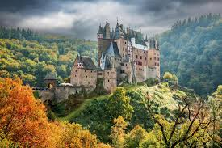 | Examples
Opening sentence:  Name the region or city where the sight is |  | Das ist die Burg Eltz in Rheinland-Pfalz bei Trier.
Second sentence:  Name the building, structure or park |  | Die Burg Eltz ist im Wald.
Possible 3rd sentence:  Describe the whole building, structure or park |  | Die Burg Eltz ist über 850 Jahre alt.
Possible 4th sentence:  Tell us one special feature of the building, structure or park |  | Die Burg Eltz ist braun mit Türmen.
Possible 5th sentence:  One more sentence of choice about the building, structure or park and/or the whole picture. |  | Die Burg Eltz ist eine Touristenattraktion.

