SAGTA Poster Competition 2023
Umbrella Topic: Brandenburg
Category | Subtopic: | Text Type to be produced | Purpose | Language features | Recommended sentence/ word count | Presentation  Requested
Years  3, 4 and 5 | Buildings, structures and parks in Brandenburg | Short statements | To inform | Simple sentences such as  Das ist….  Er/Sie/Es ist….  (Ich finde …..) | 3 to 5 sentences | Poster - A4 to A3 size  To include a picture downloaded from a free website or a drawing done by the student

Text Requirements |  | Examples
Opening sentence:  Name the building | 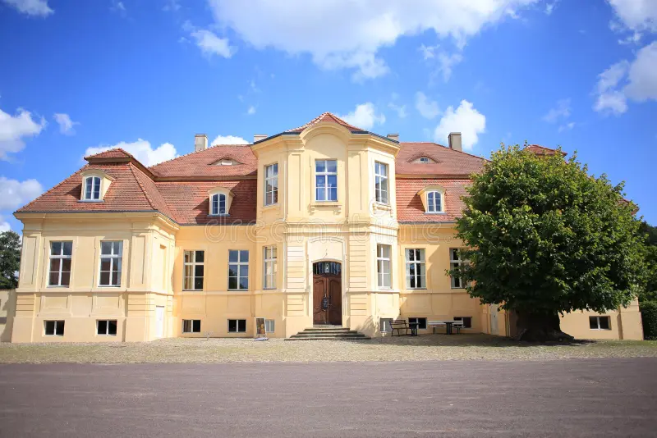 | Das ist das Schloss Reckahn.
Second sentence:  Describe where the building, structure or park is situated |  | Das Schloss liegt im Dorf Reckahn in Brandenburg.
Possible 3rd sentence:  Describe the whole building, structure or park |  | Die Familie von Rochow wohnte hier.
Possible 4th sentence:  Tell us one special feature of the building, structure or park |  | Es hat ein Museum.
Possible 5th sentence:  One more sentence of choice about the building, structure or park and/or the whole picture. |  | Das Schloss ist jetzt ein Hotel und Restaurant.

