PowerPoint für Dummies Cheat Sheet

Including animations in your PowerPoint transforms a static slide show to a dynamic and engaging presentation. In this context, ‘animation’ means programming objects (eg text or images) on your slides to move on the click of a mouse.

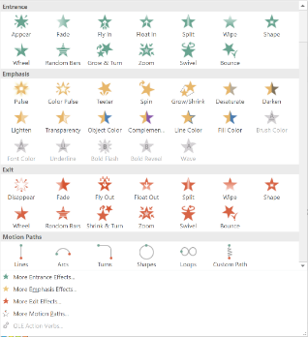**Animation Types**

Entrance Object will appear on the screen

Exit Object that was on screen will disappear

Emphasis Object draws attention to itself

Motion Path Object moves from one place to another

**How to animate an object**

Step 1: Insert desired object eg: picture / shape / text box

Step 2: Open Animations tab (will appear shaded until you select an object to animate)

Step 3: Select object to be animated and animation effect

Recommended:

1. ***Enable auto preview*** so that once you have embedded an animation it will demonstrate what it will do in the presentation.

2. ***Leave the Animation Pane open*** on the side of your working screen so that you can see what animations have been embedded on the slide

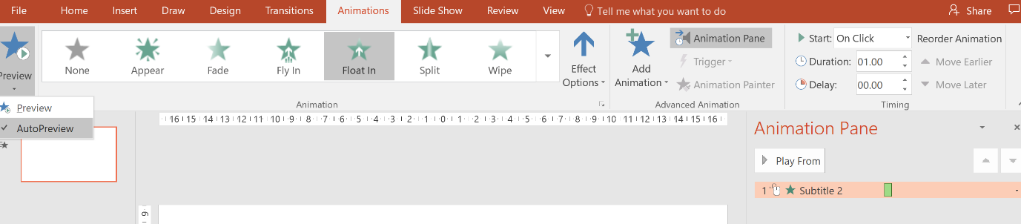

H**ow to animate objects to respond when triggered**

Step 1: Select object and animate with desired animation effect (works best with exit animations)

Step 2: Select ‘Trigger’, then ‘On click of…’ and choose the object you would like to use as the trigger – if you want the object to respond to clicking on itself, choose the one that is highlighted in the Animation Pane

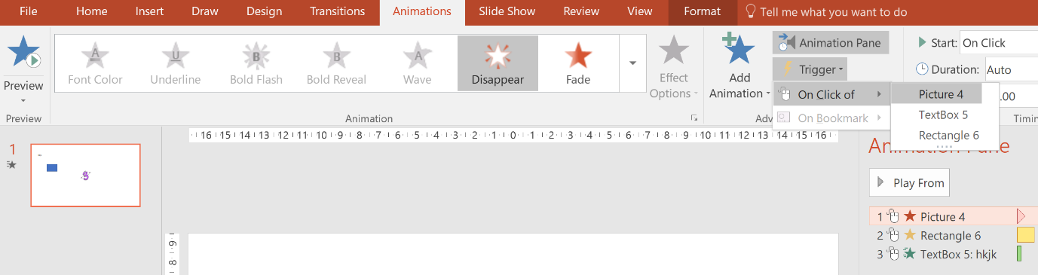

**How to add sound to animation**

Step 1: Animate object as desired

Step 2: In Animation Pane click small arrow to the right of animated object, then select Effect Options from the drop down menu

Step 3: Choose desired sound effect in the popup window

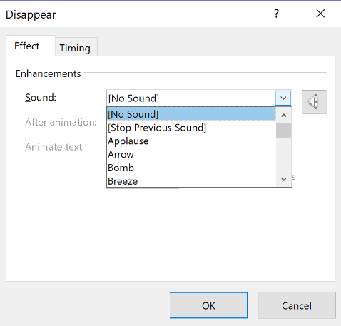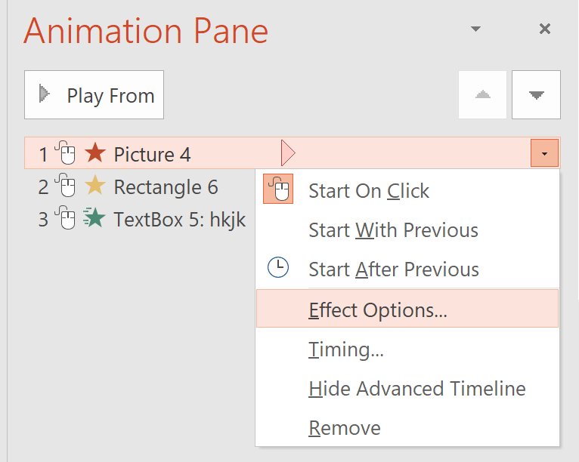

**How to apply the same animation effects to multiple objects**

Step 1: Animate first object as desired

Step 2: Click first object then select the Animation Painter (this effectively copies the animation)

Step 3: Click second object to ‘paint’ the copied animation onto it

(To paint multiple objects double-click the Animation Painter and paint all objects then click Animation Painter again to finish)

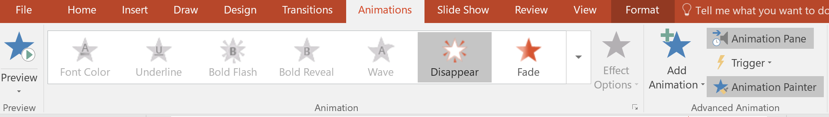

**How to insert date**

In the insert menu click ‘Date & Time’, choose preferred date format.

If you want this displayed in your language you may need to change the settings (File/Options/Language).



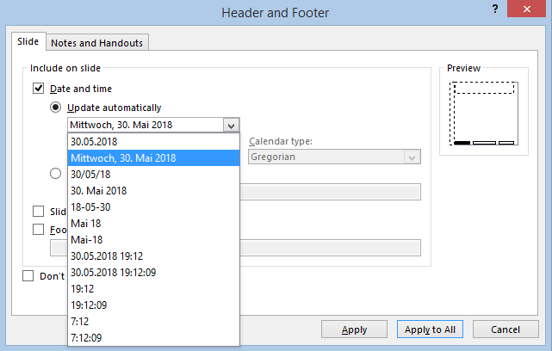

**Ideas for implementation of animations**



